TRAIN BOOKING SYSTEM

INTRODUCTION
Train Booking System is basically a database-based project developed using Python programming language and MySQL. The main purpose of this project is to provide an easy and efficient way to manage train details, passenger information, ticket bookings and cancellations.
The system allows users to register and log in using a username and password. After successful login, the user can view available train details, search for trains based on source and destination, book tickets, cancel tickets and view booking details.
The system automatically generates a unique PNR number for every ticket booking. It also assigns a seat number and updates the number of available seats after every booking or cancellation. All the important information is stored in a MySQL database and can be retrieved whenever required.
The Train Booking System reduces manual work and makes the process of managing railway bookings faster and more convenient. It also demonstrates the practical use of Python programming, MySQL database connectivity, conditional statements, loops, functions of the MySQL Connector and random number generation.

OBJECTIVES OF THE PROJECT
The main objective of this project is to apply programming and database concepts to a real-world problem. The project demonstrates how Python can be connected with MySQL to create a useful database application.
The objectives of the project are:
- To develop a simple and user-friendly Train Booking System.
- To store and manage train details using MySQL.
- To store passenger and ticket booking information.
- To provide user registration and login facilities.
- To allow users to search for trains according to source and destination.
- To book train tickets electronically.
- To automatically generate a unique PNR number.
- To assign seats to passengers.
- To update available seats after booking and cancellation.
- To provide a facility for cancelling booked tickets.
- To retrieve and display booking details easily.
- To reduce manual paperwork and human errors.
- To demonstrate the practical application of Python and MySQL.

PURPOSE
The Train Booking System is designed to provide a simple solution for managing train reservations and passenger information. In a manual railway booking system, maintaining passenger records, train details and ticket information can require considerable time and paperwork.
This project stores the required information in a MySQL database. The user can register and log in to the system and then access different facilities through a menu-driven interface.
The system provides the following facilities:
- User registration
- User login
- Train details
- Train search
- Ticket booking
- Ticket cancellation
- Booking details
When a ticket is booked, the system generates a PNR number and assigns a seat number. The available seats of the selected train are automatically reduced. When a ticket is cancelled, the available seat count is increased again.
The project demonstrates how database management can be used to make a real-world reservation system more organized, efficient and easy to operate.

MYSQL
MySQL is an open-source Relational Database Management System (RDBMS) that uses Structured Query Language (SQL). It is used to create, store, manage and retrieve data from databases.
In this project, MySQL is used to store user information, train information and booking information. The database used in this project is named register.
The project contains the following tables:
- users
- trains
- bookings
These tables store the information required by the Train Booking System.

FEATURES
- It is open source and freely available.
- It is easy to use.
- It can store a large amount of data.
- It provides fast data retrieval.
- It supports relational database operations.
- It can be connected with Python using MySQL Connector.
- It provides facilities for inserting, updating, deleting and retrieving records.

PYTHON
Python is a high-level, interpreted, general-purpose programming language. It was created by Guido van Rossum and was first released in 1991.
Python is widely used because of its simple syntax and readability. It supports different programming concepts and provides many built-in modules.
In this project, Python is used as the main programming language. The mysql.connector module is used to establish a connection between Python and the MySQL database.
The random module is used to generate a random number for creating the PNR number.

FEATURES
- Easy to learn and understand.
- Simple and readable syntax.
- Open-source programming language.
- Supports database connectivity.
- Provides many built-in modules.
- Portable and widely used.
- Suitable for developing different types of applications.
- Supports object-oriented programming.

HARDWARE AND SOFTWARE CONFIGURATION

HARDWARE
- Processor: Intel
- RAM: 4 GB or above
- Hard Disk: 80 GB or above

SOFTWARE
- Python
- MySQL
- MySQL Connector for Python
- Windows / Linux operating system

MODULES OF THE PROJECT
The Train Booking System consists of the following major modules:

1. USER REGISTRATION
New users can create an account by entering a username and password. The information is stored in the users table.

2. USER LOGIN
Registered users can enter their username and password. The system checks the details in the database before allowing access.

3. TRAIN DETAILS
The system displays the available trains along with train number, train name, source, destination, departure time, arrival time, available seats and fare.

4. SEARCH TRAINS
Users can enter the source and destination to search for matching trains.

5. BOOK TICKET
Users can enter passenger details and select a train. If seats are available, the system generates a PNR number, assigns a seat and stores the booking details.

6. CANCEL TICKET
A ticket can be cancelled by entering its PNR number. The booking is removed from the database and the available seat count is increased.

7. VIEW BOOKINGS
The system displays all the booked ticket details stored in the database.

SCREENSHOTS

TABLES CREATED

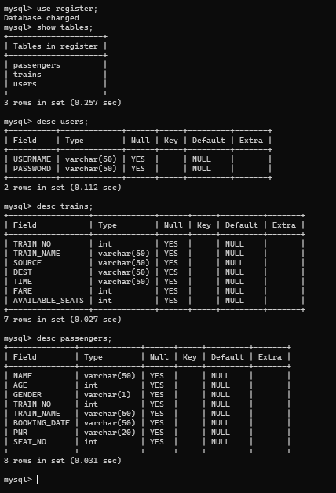

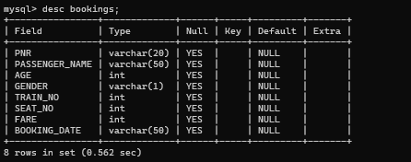

OUTPUT

USER REGISTRATION
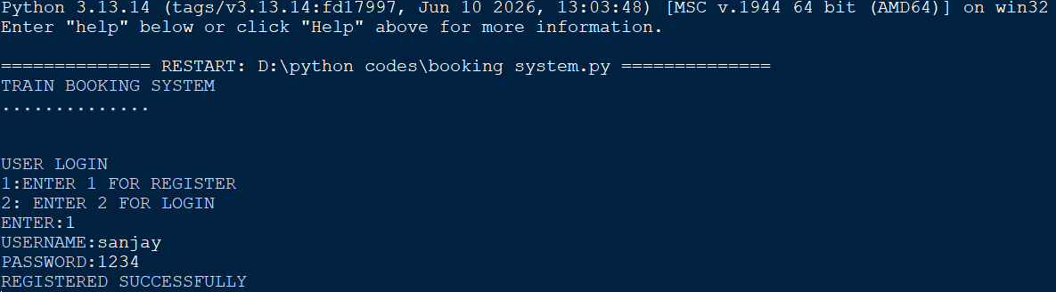

USER LOGIN

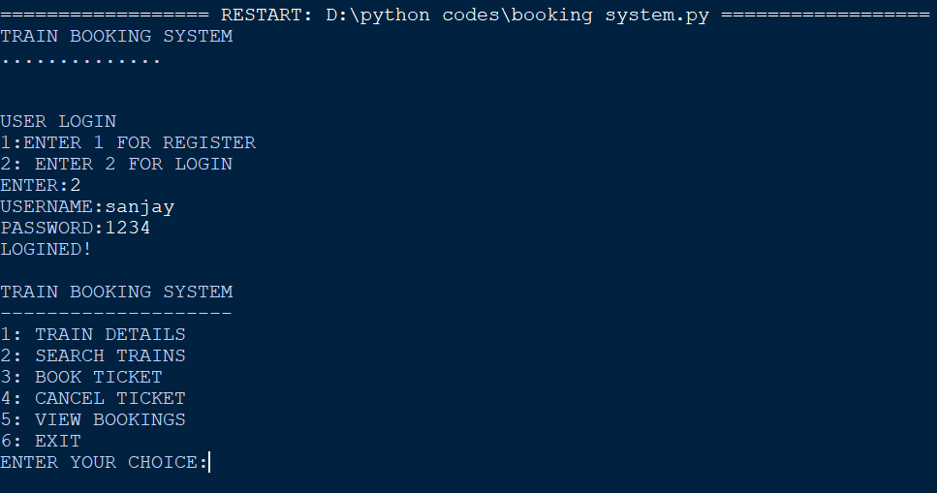TICKET BOOKING
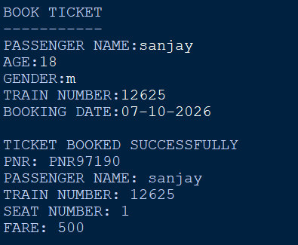

TICKET CANCELLATION
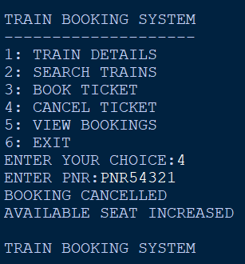

ALL BOOKED TICKETS
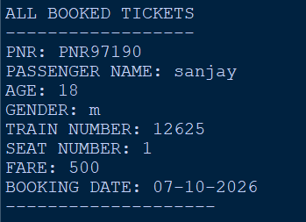

TRAIN DETAILS

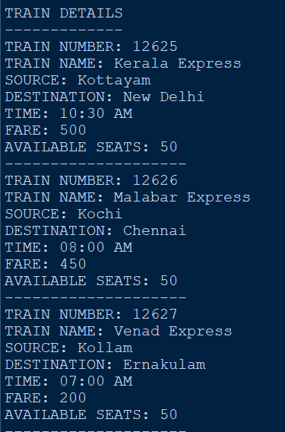

SOURCE CODE FOR TABLE CREATION
import mysql.connector as tor

my=tor.connect(host='localhost',user='root',password='12345678')
h=my.cursor()

h.execute("create database if not exists register")
h.execute("use register")

h.execute("""create table if not exists users(
USERNAME varchar(50),
PASSWORD varchar(50))""")

h.execute("""create table if not exists trains(
TRAIN_NO int,
TRAIN_NAME varchar(50),
SOURCE varchar(50),
DEST varchar(50),
TIME varchar(50),
FARE int,
AVAILABLE_SEATS int)""")

h.execute("""create table if not exists passengers(
NAME varchar(50),
AGE int,
GENDER varchar(1),
TRAIN_NO int,
TRAIN_NAME varchar(50),
BOOKING_DATE varchar(50),
PNR varchar(20),
SEAT_NO int)""")

h.execute("""create table if not exists bookings(
PNR varchar(20),
PASSENGER_NAME varchar(50),
AGE int,
GENDER varchar(1),
TRAIN_NO int,
SEAT_NO int,
FARE int,
BOOKING_DATE varchar(50))""")

my.commit()

print("TABLES CREATED SUCCESSFULLY")

my.close()

SOURCE CODE OF TRAIN BOOKING SYSTEM
import mysql.connector as tor
import random

print("TRAIN BOOKING SYSTEM")
print("....................")
print()
print("USER LOGIN")
print("""1: ENTER 1 FOR REGISTER
2: ENTER 2 FOR LOGIN""")

a=int(input("ENTER:"))

if a==1:
my=tor.connect(host='localhost',user='root',password='12345678',database='register')
h=my.cursor()
u=input("USERNAME:")
p=input("PASSWORD:")
q="insert into users(USERNAME,PASSWORD) values('{}','{}')".format(u,p)
h.execute(q)
my.commit()
print("REGISTERED SUCCESSFULLY")
my.close()

elif a==2:
my=tor.connect(host='localhost',user='root',password='12345678',database='register')
h=my.cursor()

u=input("USERNAME:")
p=input("PASSWORD:")

k="select * from users where USERNAME='{}' and PASSWORD='{}'".format(u,p)
h.execute(k)
result=h.fetchone()

if result:
print("LOGINED!")

while True:
print()
print("TRAIN BOOKING SYSTEM")
print("--------------------")
print("1: TRAIN DETAILS")
print("2: SEARCH TRAINS")
print("3: BOOK TICKET")
print("4: CANCEL TICKET")
print("5: VIEW BOOKINGS")
print("6: EXIT")

ch=int(input("ENTER YOUR CHOICE:"))

if ch==1:
my=tor.connect(host='localhost',user='root',password='12345678',database='register')
h=my.cursor()

h.execute("select * from trains")
data=h.fetchall()

print()
print("TRAIN DETAILS")
print("-------------")

for x in data:
print("TRAIN NUMBER:",x[0])
print("TRAIN NAME:",x[1])
print("SOURCE:",x[2])
print("DESTINATION:",x[3])
print("TIME:",x[4])
print("FARE:",x[5])
print("AVAILABLE SEATS:",x[6])
print("--------------------")

my.close()

elif ch==2:
my=tor.connect(host='localhost',user='root',password='12345678',database='register')
h=my.cursor()

s=input("SOURCE:")
d=input("DESTINATION:")

q="select * from trains where SOURCE='{}' and DEST='{}'".format(s,d)
h.execute(q)
data=h.fetchall()

if data:
print()
print("MATCHING TRAINS")
print("----------------")

for x in data:
print("TRAIN NUMBER:",x[0])
print("TRAIN NAME:",x[1])
print("SOURCE:",x[2])
print("DESTINATION:",x[3])
print("TIME:",x[4])
print("FARE:",x[5])
print("AVAILABLE SEATS:",x[6])
print("--------------------")
else:
print("NO TRAIN FOUND!")

my.close()

elif ch==3:
my=tor.connect(host='localhost',user='root',password='12345678',database='register')
h=my.cursor()

print()
print("BOOK TICKET")
print("-----------")

n=input("PASSENGER NAME:")
age=int(input("AGE:"))
g=input("GENDER:")
tn=int(input("TRAIN NUMBER:"))
bd=input("BOOKING DATE:")

q="select * from trains where TRAIN_NO={}".format(tn)
h.execute(q)
train=h.fetchone()

if train:
seats=train[6]
fare=train[5]

if seats>0:
seat=50-seats+1
pnr="PNR"+str(random.randint(10000,99999))

q="insert into bookings(PNR,PASSENGER_NAME,AGE,GENDER,TRAIN_NO,SEAT_NO,FARE,BOOKING_DATE) values('{}','{}',{},'{}',{},{},{},'{}')".format(pnr,n,age,g,tn,seat,fare,bd)

h.execute(q)

q="update trains set AVAILABLE_SEATS=AVAILABLE_SEATS-1 where TRAIN_NO={}".format(tn)
h.execute(q)

my.commit()

print()
print("TICKET BOOKED SUCCESSFULLY")
print("PNR:",pnr)
print("PASSENGER NAME:",n)
print("TRAIN NUMBER:",tn)
print("SEAT NUMBER:",seat)
print("FARE:",fare)

else:
print("NO AVAILABLE SEATS!")

else:
print("TRAIN NOT FOUND!")

my.close()

elif ch==4:
my=tor.connect(host='localhost',user='root',password='12345678',database='register')
h=my.cursor()

pnr=input("ENTER PNR:")

q="select TRAIN_NO from bookings where PNR='{}'".format(pnr)
h.execute(q)
data=h.fetchone()

if data:
tn=data[0]

q="delete from bookings where PNR='{}'".format(pnr)
h.execute(q)

q="update trains set AVAILABLE_SEATS=AVAILABLE_SEATS+1 where TRAIN_NO={}".format(tn)
h.execute(q)

my.commit()

print("BOOKING CANCELLED")
print("AVAILABLE SEAT INCREASED")

else:
print("INVALID PNR!")

my.close()

elif ch==5:
my=tor.connect(host='localhost',user='root',password='12345678',database='register')
h=my.cursor()

h.execute("select * from bookings")
data=h.fetchall()

print()
print("ALL BOOKED TICKETS")
print("------------------")

if data:
for x in data:
print("PNR:",x[0])
print("PASSENGER NAME:",x[1])
print("AGE:",x[2])
print("GENDER:",x[3])
print("TRAIN NUMBER:",x[4])
print("SEAT NUMBER:",x[5])
print("FARE:",x[6])
print("BOOKING DATE:",x[7])
print("--------------------")
else:
print("NO BOOKINGS FOUND!")

my.close()

elif ch==6:
print("THANK YOU FOR USING TRAIN BOOKING SYSTEM")
break

else:
print("WRONG CHOICE!")

my.close()

else:
print("CHECK YOUR USERNAME AND PASSWORD!")

else:
print("YOU HAVE ENTERED A WRONG CHOICE")

CONCLUSION
The Train Booking System is a database-based application developed using Python and MySQL. The project provides a simple and efficient method for managing train details, user accounts, passenger information and ticket bookings.
The system allows users to register and log in securely, search for trains, book tickets, cancel tickets and view booking information. It also automatically generates a PNR number and updates the available seats whenever a ticket is booked or cancelled.
This project helped in understanding the practical application of Python programming and MySQL database management. It also demonstrates how programming can be used to solve real-world problems and reduce manual work.
Overall, the Train Booking System provides a simple, organized and efficient method of managing railway ticket reservations.

BIBLIOGRAPHY
- Computer Science With Python – Class XI and XII
By Sumita Arora
- Computer Science With Python – Class XI and XII
By Preeti Arora
- Computer Science With Python – Class XI and XII
By V.K. Pandey and D.K. Dey
- MySQL Documentation
- Python Documentation

